**Demonstrate Pentaho's 4.0 RC1 Ability to Burst Reports to File System and Email**

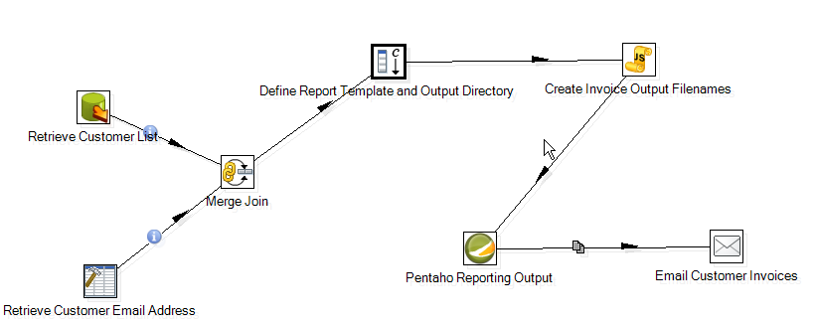

Please see attached KTR and make the following modifications (This example r 4.0 RC1):

A. Edit the following fields in the Define Report Template and Output Directory step (Add constant values step):

1. invoice_report - Verify the path is the same as your path on your computer
2. output_directory - Verify the path is the same as your path on your computer
3. senderEmail- This email address will be the email that is displayed as the email address that the report came from
4. smtpServer - Enter your SMTP Server information here
5. port - Enter the port number for your SMTP server
6. username - Enter the username for your email
7. pass - Enter the password for your email

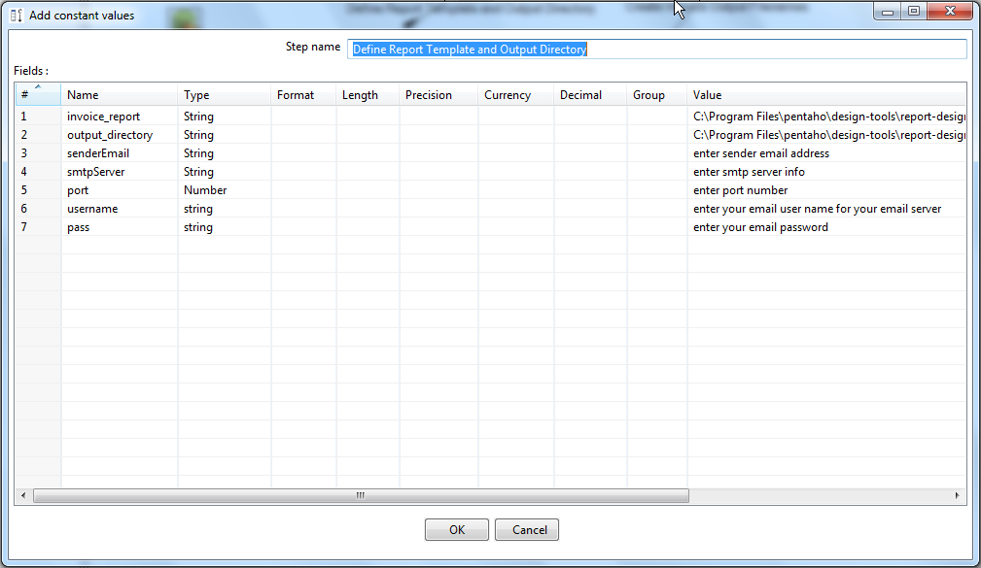

B. Edit the Retrieve Customer Email Address Step (Add Constant Rows Step)

1. Click on the Data Tab
2. Edit the customerEmail addresses to represent a real email address (This example produces invoices for 5 customers so 5 email addresses are needed. You can use the same email address and 5 separate emails will be sent to that email address.

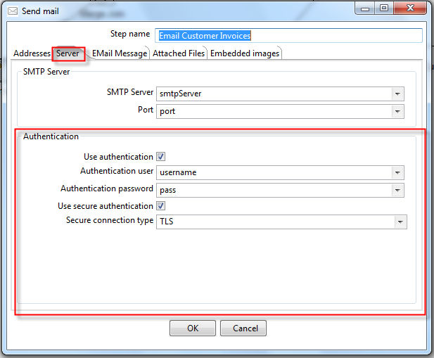

C. Edit the Authentication portion of the Email Customer Invoices step (Send email step)

1. Select your Authentication Options (if any) for your SMTP Server.

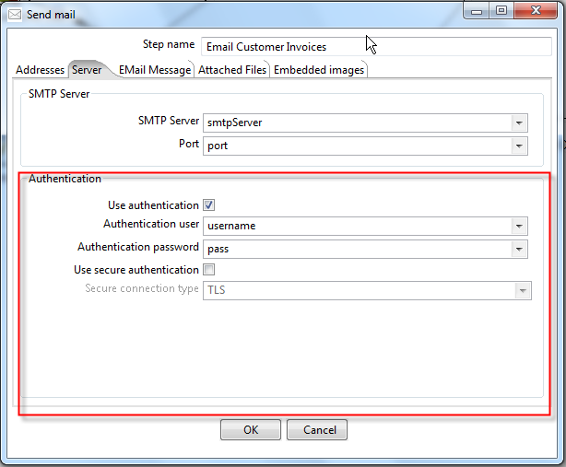

You can now save and run your transformation.